Educator Reflective Questions for Learning Stories

Think about the following before and as you write your Learning Story / Observations. These will prompt your thinking.

- Why is this observation significant?
- What new knowledge / skill am I seeing?
- What learning style is evident? Consider Gardner’s Multiple Intelligence
- Have I seen this before- when / how/ why?
- What new information do I now have about this child?
- Can I “see” who this child is in my documentation? Think about descriptive language
- Can I “see” my role as a co-constructor / collaborator in this documentation?
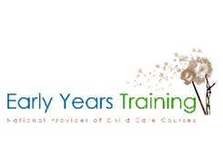
- Have I described the way the child engaged?
- Have I focused on learning and development… or have I focused on the activity?

